



**Tomorrow’s Education Journal**

eISSN: 2988-3318, Vol 1, No 1, 2024, pp 1-5

**THE EFFECTIVENESS OF THE BEELINGUAPP APPLICATION TO IMPROVE EFL LEARNERS' READING COMPREHENSION ON NARRATIVE TEXT AT SMKN I CIREBON**

**Nurlaela Rahmawati** Institut Prima Bangsa [nurlailarw@gmail.com](mailto:nurlailarw@gmail.com)

**Dwi Nopiyadi** Institut Prima Bangsa [dwinopiyadi@gmail.com](mailto:dwinopiyadi@gmail.com)

**Article History**: Accepted August 2024;

Revised September 2024;

Approved October 2024.

**H. Lili Sururi Asipi** Institut Prima Bangsa [Kiaikampung70@gmail.com](mailto:Kiaikampung70@gmail.com)

**Abstract:** This study aims to assess the effectiveness of the Beelinguapp application in improving EFL students' reading comprehension of narrative texts at SMKN I Cirebon and to

determine the benefits of implementing this technology in the learning process. English language skills are crucial both globally and within the Indonesian education system. EFL (English as a Foreign Language) learners often struggle with reading comprehension, a critical skill that involves various cognitive processes and understanding the meaning of texts. Narrative texts, which are engaging and rich in moral values, are favored by students. This research use a quantitative approach was employed using an experimental method with a pretest-posttest design and questionnaires. The study sample consisted of 60 students from Class X TEI 1 - TEI 4, selected through random sampling. Data collection techniques included a pretest, posttest, and questionnaire administered to the experimental group. The results indicated a significant improvement in reading comprehension, with a t-value of 8.029, which is greater than the t-table value of 2.022 (Sig. 2-Tailed = 0.000 < 0.05). Thus, the null hypothesis (H0) was rejected, and the alternative hypothesis (Ha) was accepted, confirming that Beelinguapp positively and significantly impacts reading comprehension of narrative texts. Additionally, student feedback from questionnaires revealed cognitive improvements in learning outcomes, particularly in reading comprehension, after the application of the Beelinguapp in the learning process.

**Keywords**: *Beelinguapp Application, Narrative Text, Reading Comprehension*

# INTRODUCTION

This research aims to test the effectiveness of the Beelinguapp application in improving reading comprehension of narrative texts by EFL students at SMKN I Cirebon. English, as a global language, is increasingly important in various aspects of life, including communication, commerce and education. According to the English Proficiency Index (2024), Indonesia is ranked 79th out of 113 countries based on English language proficiency, and 13th out of 23 countries in Asia. Students' English proficiency at school is still relatively low, with EFL students often lacking motivation, having difficulty learning the right skills, and having difficulty finding the main ideas in texts.

In recent scientific explanations, much attention has been directed towards investigating the effectiveness of using applications in the teaching and learning process. In particular, research conducted by Juliani (2020) states that Beelinguapp has interesting features for students to improve reading comprehension. This application works by displaying text to the user in two languages simultaneously, this application also functions as an audiobook. So that students can stand by listening to the voice account while reading the text, as well as karaoke-style movements running through the text that can be accessed, using the BeelinguApp application can make students more comfortable and enjoy learning thereby increasing interest in reading comprehension, especially in subjects. understand narrative text.

Apart from the many researchers who test the effectiveness of using applications in the teaching and learning process, the material taught is also key, one of which is narrative text. The narrative text is one of the genres that students are most interested in because it contains a moral message and can be entertaining.

Technology has an important role in language learning, especially in increasing motivation and reading comprehension. Beelinguapp, an application that displays texts in two languages simultaneously and functions as an audiobook, is a potential solution to improve reading comprehension of narrative texts in EFL learners. This application is designed to help support language learning through the concept of bilingual reading, which allows students to process texts in the target language with translation in their native language.

This research is important because EFL learners are not yet accustomed to using applications in the learning process. It is hoped that Beelinguapp can help overcome their difficulties in understanding English texts and improve their reading skills.

# METHODOLOGY

The methodology employed in this study is quantitative, as defined by Priadana and Sunarsi (2021). Quantitative research aims to comprehensively understand phenomena by gathering data from natural settings, with the researcher acting as the primary instrument. This approach emphasizes measuring and analyzing causal relationships between different variables.

The instruments used in this research were tests and questionnaires. Researchers classified reading test questions based on the five aspects of reading comprehension proposed by Sridharan & Said, (2020), namely determining the main idea, identifying references, making conclusions, detailing information, and interpreting vocabulary. and questionnaire used in this research by Fadillah & Zainurossalamia, (2023) consisting of six indicator namely, easy to learn, controllable, clear and understandable , flexible, easy to become proficient, and easy to use.A literature review

# FINDINGS AND DISCUSSION

**Effectivitass Beelinguapp Application**

Based on the results of research and hypothesis testing conducted on TEI 1 - 4 Smkn 1 Cirebon students class 2023/2024, the Beelinguapp application has the effect of increasing reading comprehension in narrative texts. The results of the study based on the t-test stated that it had a significant value of 0.00 < 0.05, meaning significance, while a tcount value of 8.029 was obtained with a tobserve value of 2.002. So it was stated that the tcount value was 8.029 > 2.002 ttable, so this was stated that Ho was rejected and Ha was accepted. Therefore, it can be concluded that the Beelinguapp application has a significant effect on improving reading comprehension in narrative texts.

According to Pavlenko et al. (2019) Beelinguapp is designed to facilitate language learning through the parallel display of text in two languages. Leveraging the concept of bilingual reading, the app presents content in the target language to users along with translations in their native language. This dual language approach increases students' reading comprehension to a greater depth.

The results of this study are also supported by previous research according to Juliani, (2020) titled The effect of Beelinguapp application toward students' reading comprehension using Kwl Strategy on narrative text of Eight grade at smpn Rokan IV Koto The results of this study beelinguapp application and KWL strategy have a positive and significant effect on students' reading ability and by utilizing the application students' interest in learning is more increased.

# Benefit Use Beelinguapp Application

From the results of the questionnaire data obtained regarding the benefits of the beelinguapp application for students in learning reading comprehension in narrative text as follows:

1. In the first indicator, namely Easy to Learn, students' responses to the use of the BeelinguApp application which was implemented during the learning process had an average score percentage of 76% including the "Good" criteria.
2. In the second indicator, namely Controlled, the response obtained by students was that it was easier for students to master it with an average percentage of 79% including the " Good" criteria.
3. In the third indicator, namely Clear and Understandable, students show an increased understanding of narrative text through the BeelinguApp application. This can be seen in the results of the post-test scores given by researchers to students with an average percentage of 80% including the " Very Good" criteria.
4. In the fourth indicator, namely Flexible, optimistic students show an increase in understanding of narrative texts through the BeelinguApp application due to flexible learning with a percentage of 77% with the criteria "Good".
5. In the fifth indicator, namely Easily proficient, students show increased understanding of narrative texts through the beelinguapp application media because they are easily proficient, with an average percentage of 78% including the "Very Good" criteria.
6. In the sixth indicator, namely Easy to use, students show increased understanding of narrative texts through the beelinguapp application because it is easy to use, with an average percentage of 81% including the " Very Good"

criteria.Multimodality has two types, there are modes and mediums. Mode refers to the symbolic system used to send messages or information, such as text, images, sound, and gestures. Whereas medium refers to the tools or channels used to transmit messages or information, such as books, computer screens, or mobile devices.

questionnaire results from an experimental class which in the teaching and learning process used an application, namely the beelinguapp application

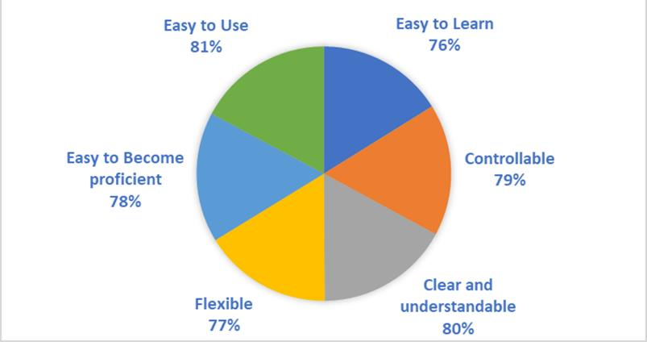

All EFL learners experienced benefits from using the Beelinguapp application to enhance their reading comprehension of narrative texts, The average score of 6 indicators is 78% “Good” reflecting an overall positive response. The application significantly impacts the reading comprehension skills of SMKN 1 Cirebon students. When utilized effectively, the Beelinguapp

application can greatly improve student understanding

# CONCLUSION

Implementing the use of applications in the learning process is one of the factors that improves student learning outcomes. With advances in technology, it can support the process of implementing teaching and learning activities. Based on the results of the student response questionnaire, it shows that almost all students feel the benefits in the learning process by using mind maps through visual learning media, meaning that the overall student response is positive.

This was agreed by the English subject teacher at SMKN 1 Cirebon City, namely Mrs. Yossi A. Wulandari, S.Pd, that the use of applications such as BeelinguApp creates a new and interesting atmosphere in the implementation of the learning process, making it easier for students to understand the material being taught.

The use of applications such as BeelinguApp has a big influence on student learning outcomes, especially reading comprehension. If the use of applications such as BeelinguApp is done well, it will influence good learning outcomes. Good learning outcomes will result in a score above the minimum completeness criteria (KKM), so that learning objectives will be achieved optimally.

# REFERENCE

Priadana.,S., & Sunarsi, D. (2021).Metode Peneitian Kuantitatif. Tanggerang Selatan: Pascal Books.

Fadillah, W., & Zainurossalamia, S. Z. (2023). Pengaruh Persepsi Kemudahan Penggunaan dan Persepsi Manfaat Terhadap Minat Menggunakan Aplikasi Canva. *MAMEN (Jurnal Manajemen)*, *2*(2), 231–240. https://doi.org/10.55123/mamen.v2i2.1808

Juliani, H. (2020). *the Effect of Beelinguapp Application Toward Students’ Reading Comprehension Using Kwl Strategy on Narrative Text of Eighth Grade At Smpn 3 Rokan Iv Koto*.

Pavlenko, O. O., Bondar, O. Y., Yon, B. G., Kwangoon, C., Tymchenko-Mikhailidi, N. S., & Kassim, D. A. (2019). The enhancement of a foreign language competence: Free online resources, mobile apps, and other opportunities. *CEUR Workshop Proceedings*, *2433*, 279– 293. https://doi.org/10.55056/cte.391

Sridharan and Said. (2020). The Effect of Graphic Organizer (KWL Chart) on Young Learners’ Reading Comprehension in an ESL Setting. *International Journal of Management and Humanities*, *4*(8), 43–53. https://doi.org/10.35940/ijmh.h0768.044820